ALU DESIGN SPECIFICATION
Document Version: 1.0
Date: April 1, 2026
Author: Meenal Pannse /Priya Ananthankrishnan
Table of Contents
- Overview
- Parameters
- Interface Signals
- Operation Description
- Arithmetic Operations
- Logical Operations
- Rotate Operations
- Reset Behavior
- Identified Bugs
- Timing Diagram
- Usage Example
- Design Limitations
- Recommended Fixes
1. Overview
This document specifies the design of a configurable Arithmetic Logic Unit (ALU) with parameterizable data width and command width. The ALU supports both arithmetic and logical operations with multi-cycle instruction capability.
1.1 Features
- Parameterizable data width (DW) and command width (CW)
- Two-stage input capture mechanism using INP_VALID signals
- Support for 3-cycle arithmetic operations (multiplication with pre-processing)
- Arithmetic and logical operation modes
- Flag outputs for comparison, carry, overflow, and error conditions
- Clock enable and reset functionality
- Waiting for 16 clock cycles to get the second operand after first operand is valid, and if not the design timesout giving an err signal high
- The last two operand has the highest priority when it comes in the wait cycle . If the operand A has come and operand B has come only on 10th clock cycle then if operand A has changed on 9th cycle then that latest value of operand A is considered for operation.
2. Parameters
Parameter | Default | Description
DW | 8 | Data width in bits for operands and result
CW | 4 | Command width in bits for operation selection
3. Interface Signals
3.1 Input Ports
Signal | Width | Description
OPA | DW-1:0 | Operand A input
OPB | DW-1:0 | Operand B input
CLK | 1 | System clock
RST | 1 | Asynchronous reset (active high)
CE | 1 | Clock enable (active high)
MODE | 1 | Operation mode (1=Arithmetic, 0=Logical)
CIN | 1 | Carry-in for arithmetic operations
CMD | CW-1:0 | Command/operation code
INP_VALID | 1:0 | Input valid control signal
3.2 INP_VALID Encoding
INP_VALID | Operation
2'b01 | Capture OPA only
2'b10 | Capture OPB only
2'b11 | Capture both OPA and OPB
Others | Clear captured operands
3.3 Output Ports
Signal | Width | Description | Default
RES | DW*2-1:0 | Result output | 'b0
COUT | 1 | Carry out (for addition) | 1'b0
OFLOW | 1 | Overflow flag (for subtraction) | 1'b0
G | 1 | Greater than flag (compare) | 1'b0
E | 1 | Equal flag (compare) | 1'b0
L | 1 | Less than flag (compare) | 1'b0
ERR | 1 | Error flag (for rotate operations and timeout) | 1'b0
4. Operation Description
4.1 Input Capture Stage
The ALU captures inputs based on INP_VALID signal on the positive edge of CLK:
- INP_VALID = 2'b01: Captures OPA into internal register oprd1
- INP_VALID = 2'b10: Captures OPB into internal register oprd2
- INP_VALID = 2'b11: Captures both OPA and OPB simultaneously
- Others: Clears both internal registers
The command (CMD) is captured simultaneously with operand(s).
4.2 Execution Stage
Operations are executed on the positive edge of CLK when CE is high and RST is low.
5. Arithmetic Operations (MODE = 1)
CMD | Operation | Description | Flags
4'b0000 | ADD | RES = oprd1 + oprd2 | COUT
4'b0001 | SUB | RES = oprd1 - oprd2 | OFLOW
4'h2 | ADD_CIN | RES = oprd1 + oprd2 + CIN | COUT
4'b0011 | SUB_CIN | RES = oprd1 - oprd2 - CIN | OFLOW
4'b0100 | INC_A | RES = oprd1+1 | -
4'b0101 | DEC_A | RES = oprd1 - 1 | -
4'b0110 | INC_B | RES = oprd2 + 1 | -
4'b0111 | DEC_B | RES = oprd2 - 1 | -
4'b1000 | CMP | Compare oprd1 and oprd2 | G/E/L flags set based on comparison
4'b1001 | MUL_INC | 3-cycle: AU_out_tmp1 = oprd1 + 1  AU_out_tmp2 = oprd2 + 1  RES = AU_out_tmp1 × AU_out_tmp2 | -
4'b1010 | MUL_SHL | 3-cycle: AU_out_tmp1 = oprd1 << 1  AU_out_tmp2 = oprd2  RES = AU_out_tmp1 * AU_out_tmp2 | -
5.1 Compare Operation Details (CMD=4'b1000)
Condition | G | E | L
oprd1 == oprd2 | 1'b0 | 1'b1 | 1'b0
oprd1 > oprd2 | 1'b1 | 1'b0 | 1'b0
oprd1 < oprd2 | 1'b0 | 1'b0 | 1'b1
6. Logical Operations (MODE = 0)
CMD | Operation | Description | Flags
4'b0000 | AND | RES = {1'b0, oprd1 & oprd2} | -
4'b0001 | NAND | RES = {1'b0, ~(oprd1 & oprd2)} | -
4'b0010 | OR | RES = {1'b0, oprd1 | oprd2} | -
4'b0011 | NOR | RES = {1'b0, ~(oprd1 | oprd2)} | -
4'b0100 | XOR | RES = {1'b0, oprd1 ^ oprd2} | -
4'b0101 | XNOR | RES = {1'b0, ~(oprd1 ^ oprd2)} | -
4'b0110 | NOT_A | RES = {1'b0, ~oprd1} | -
4'b0111 | NOT_B | RES = {1'b0, ~oprd2} | -
4'b1000 | SHR1_A | RES = {1'b0, oprd1>>1} | -
4'b1001 | SHL1_A | RES = {1'b0, oprd1 << 1} | -
4'b1010 | SHR1_B | RES = {1'b0, oprd2 >> 1} | -
4'b1011 | SHL1_B | RES = {1'b0, oprd2 << 1} | -
4'b1100 | ROL_A_B | Rotate left oprd1 by amount specified in oprd2[2:0] | ERR=1 if oprd2[7:4] ≠ 0
4'b1101 | ROR_A_B | Rotate right oprd1 by amount specified in oprd2[2:0] | ERR=1 if oprd2[7:4] ≠ 0
7. Rotate Operations
7.1 ROL_A_B (CMD=4'b1100)
Rotates oprd1 left by the number of bits specified in oprd2[2:0]:
oprd2[2:0] | Rotation Amount
3'b000 | 0 bits (no rotation)
3'b001 | 1 bit left
3'b010 | 2 bits left
3'b011 | 3 bits left
3'b100 | 4 bits left
3'b101 | 5 bits left
3'b110 | 6 bits left
3'b111 | 7 bits left
Error Condition: If any bit in oprd2[7:4] is 1, ERR is set to 1.
7.2 ROR_A_B (CMD=4'b1101)
Rotates oprd1 right by the number of bits specified in oprd2[2:0].
8. Reset Behavior
When RST is active high:
Signal | Value
RES | 'b0
COUT | 1'b0
OFLOW | 1'b0
G/E/L | 1'b0
ERR | 1'b0
Internal registers | 0

9. Timing Diagram
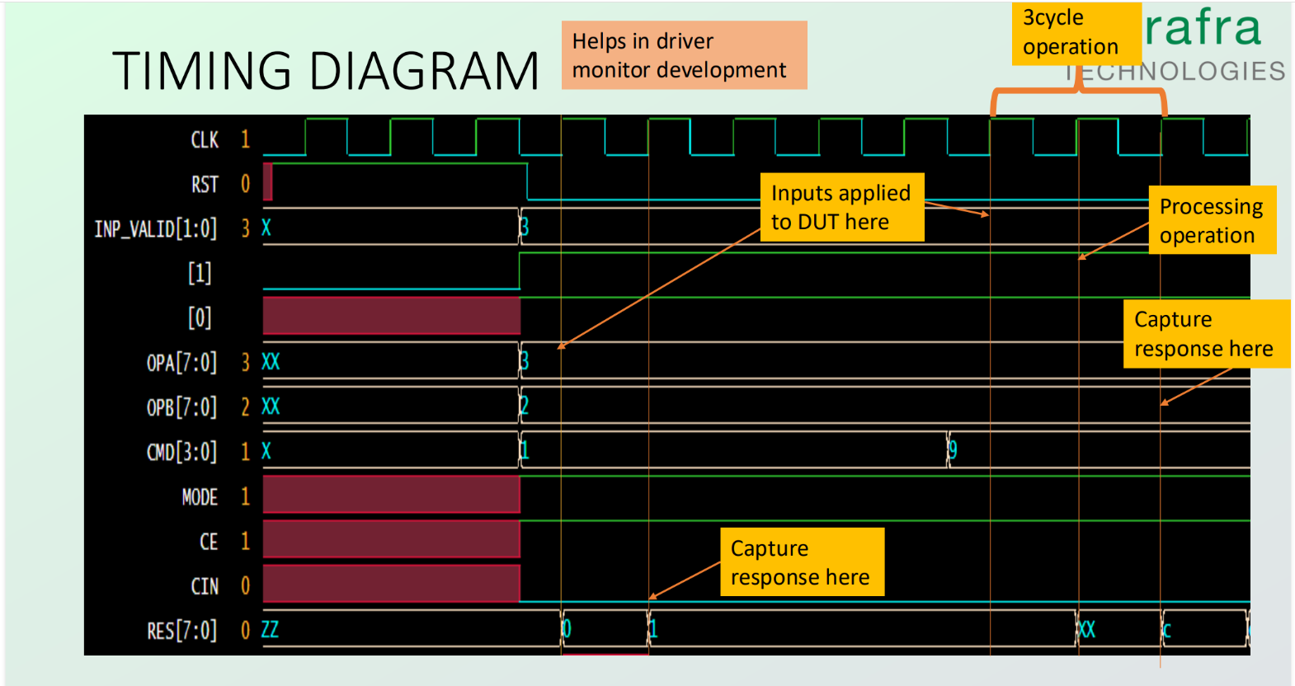Multi-cycle Operation (CMD=4'b1001/1010):
- Cycle 1: Capture inputs and compute intermediate values
- Cycle 2: Store intermediate results
- Cycle 3: Perform final operation and output result

11. Design Limitations
- Multi-cycle operations: Results for CMD=4'b1001 and 4'b1010 are delayed by 2 additional clock cycles
- Result width: Result is DW*2 bits to accommodate carry and overflow

